Webinar on New Urban Agenda Reporting

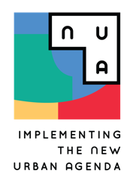Concept Note

# SUMMARY

## Webinar Title

## *Monitoring the Transformative Commitments and the Means of Implementation of the New Urban Agenda*

## Long Term Learning Goal

The goal of this webinar is to further train national governments to effectively report on the implementation of the New Urban Agenda (NUA). The webinar specifically aims to increase both the quantity and quality of submissions of NUA National Progress Reports and serves as an in-depth moderated learning session on the revised national reporting guidelines.

The webinar supports the broader efforts of UN-Habitat to build and mobilize a broad coalition of stakeholders to implement the New Urban Agenda through the three elements: reporting, mainstreaming, and achieving the agenda’s principles on the ground.

## Learning Objectives

After completing the webinar, the learner is able to:

* To have in-depth knowledge on National Progress Reporting processes
* To enhance the quality of National Progress Reports

## Duration

2 hours (1.5 hours recommended)

## Target learners

* National stakeholders preparing National Progress Reports
* Representatives from regional bodies engaging in the NUA monitoring and reporting processes
* Learners who are willing to join the NUA monitoring and reporting processes

## Precondition

Participants are required to

* take the e-learning course: *Monitoring the Transformative Commitments of the New Urban Agenda* before attending the webinar
* submit the e-learning certificate to participate the webinar

## Certification

Learners who attend the webinar full time and submit a survey will obtain a certificate.