Webinar on New Urban Agenda Reporting

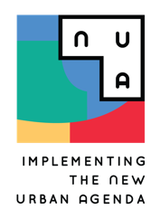Ice-breaking Questions

# SUMMARY

## Webinar Title

# *Monitoring the Transformative Commitments and the Means of Implementation of the New Urban Agenda*

# Questions

1. Until when does the New Urban Agenda remain in effect?
   1. 2028
   2. 2030
   3. 2036
   4. 2040
2. What is the status of your country's NUA National Progress Report?
   1. My country submitted a report in the last cycle
   2. My country is currently preparing a report
   3. My country has never submitted or started preparing a report
   4. I am not sure
3. On a scale from 0 to 10 how well do you think the world is progressing towards achieving the principles set out in the NUA?
4. What do you see as the biggest obstacle for national governments in reporting on the New Urban Agenda?

# 